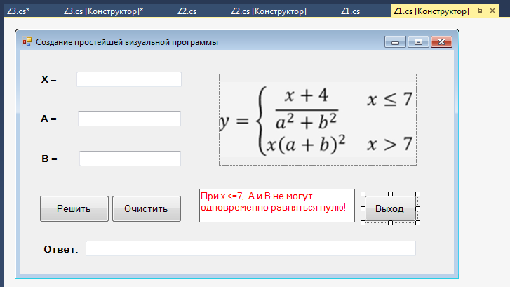

using System;

using System.Collections.Generic;

using System.ComponentModel;

using System.Data;

using System.Drawing;

using System.Linq;

using System.Text;

using System.Threading.Tasks;

using System.Windows.Forms;

namespace Zadanie1

{

public partial class Z1 : Form

{

public Z1()

{

InitializeComponent();

}

private void textBox4_TextChanged(object sender, EventArgs e)

{

}

private void button1_Click(object sender, EventArgs e)

{

double x = Convert.ToDouble(textBox1.Text);

double a = Convert.ToDouble(textBox2.Text);

double b = Convert.ToDouble(textBox3.Text);

double y;

if (x <= 7 && (a!=0 ||b!=0)) y = (x+4)/(a*a+b*b);

else y = x*(a+b)*(a+b);

textBox5.Text = " " + y;

}

private void button3_Click(object sender, EventArgs e)

{

this.Close();

}

private void button2_Click(object sender, EventArgs e)

{

textBox1.Text = "";

textBox2.Text = "";

textBox3.Text = "";

}

}

}

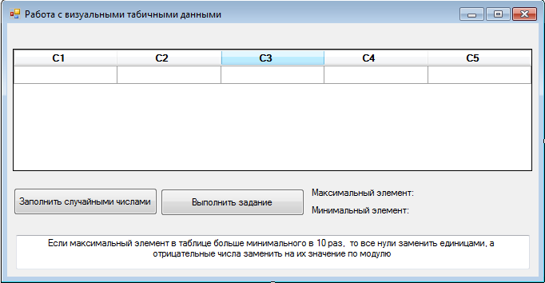

using System;

using System.Collections.Generic;

using System.ComponentModel;

using System.Data;

using System.Drawing;

using System.Linq;

using System.Text;

using System.Threading.Tasks;

using System.Windows.Forms;

namespace Zadanie2

{

public partial class Z2 : Form

{

int[,] array = new int[5, 5];

Random Rand = new Random();

public Z2()

{

InitializeComponent();

}

private void button1_Click(object sender, EventArgs e)

{

dataGridView1.RowCount = 5;

dataGridView1.ColumnCount = 5;

for (int i = 0; i < 5; i++)

{

dataGridView1.Rows[i].HeaderCell.Value ="C"+ (i + 1).ToString();

for (int j = 0; j < 5; j++)

{

dataGridView1.Columns[j].HeaderCell.Value = "C" + (j + 1).ToString();

array[i, j] = Rand.Next(-50, 50);

dataGridView1[j, i].Value = array[i, j].ToString();

}

}

}

private void button2_Click(object sender, EventArgs e)

{

int max = array[0, 0];

int min = array[0, 0];

for (int i = 0; i < 5; i++)

{

for (int j = 0; j < 5; j++)

{

if (max < array[i, j]) max = array[i, j];

if (min > array[i, j]) min = array[i, j];

}

}

label3.Text = max.ToString();

label4.Text = min.ToString();

if (max / min == 10)

{

for (int i = 0; i < 5; i++)

{

for (int j = 0; j < 5; j++)

{

if (array[i, j]==0) array[i, j]=1;

if (array[i, j]<0) array[i, j]=-array[i, j];

dataGridView1[j, i].Value = array[i, j].ToString();

}

}

}

}

}

}

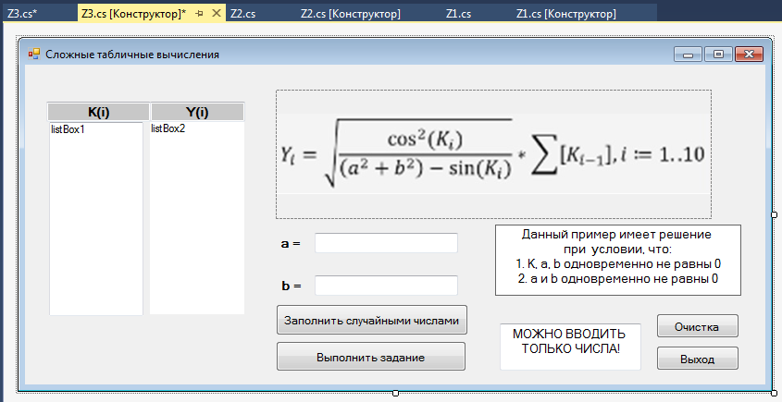

using System;

using System.Collections.Generic;

using System.ComponentModel;

using System.Data;

using System.Drawing;

using System.Linq;

using System.Text;

using System.Threading.Tasks;

using System.Windows.Forms;

namespace Zadanie3

{

public partial class Z3 : Form

{

Random Rand = new Random();

public Z3()

{

InitializeComponent();

}

private void textBox3_TextChanged(object sender, EventArgs e)

{

}

private void textBox4_TextChanged(object sender, EventArgs e)

{

}

private void button1_Click(object sender, EventArgs e)

{

listBox1.Items.Clear();

int n = 10;

for (int i = 0; i <= n; i++)

{

double k = Rand.Next(0, 50) - Rand.NextDouble();

listBox1.Items.Add(k);

}

}

private void button2_Click(object sender, EventArgs e)

{

int n = 10;

double m = 0;

for (int i = 0; i <= n; i++)

{

double a = Convert.ToDouble(textBox1.Text);

double b = Convert.ToDouble(textBox2.Text);

double k = Rand.Next(0, 50) - Rand.NextDouble();

double y = Math.Sqrt(Math.Cos(k)* Math.Cos(k)/((a*a+b*b)- Math.Sin(k)))*m;

m = m + k;

listBox2.Items.Add(y);

}

}

private void button3_Click(object sender, EventArgs e)

{

textBox1.Text = "";

textBox2.Text = "";

listBox1.Items.Clear();

listBox2.Items.Clear();

}

private void button4_Click(object sender, EventArgs e)

{

this.Close();

}

}

}